Need the below on our website ---- likely on the open jobs page if possible?

Equal Employment Opportunity
Qualified applicants will receive consideration for employment without regard to race, color, religion, sex, national origin, disability, protected veteran status or other characteristics protected by state or federal law.

Know Your Rights: Workplace Discrimination is Illegal – link to poster
Pay Transparency – link to poster
Employee Polygraph Protection Act - link to poster

Need assistance?
If you need accommodation assistance during the application process, simply email us at HumanResources@nine30consulting.com.

Examples:
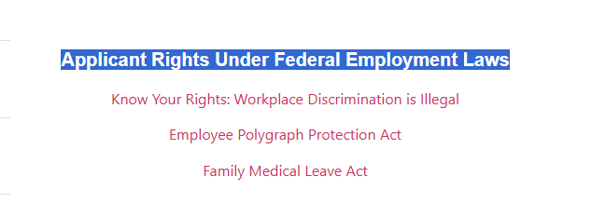

https://www.milcorp.com/careers/careers/
I like this one!
